## BHARATHIYAR UNIVERSITY,COIMBATORE KATHIR COLLEGE OF ARTS AND SCINCE

**BSC COMPUTER SCIENCE**

**Project Title :** To Supply Leftover Food To Poor

**Role : SALESFORCE DEVELOPER**

**Team LEADER : IMMANUVEL PRASANARAJ.S**

**TEAM MEMBERS** **:**

DILIPAN.M

NISHANTH.S

MANIKANDAN.K

**Academic Year :** 2025 -2026

**Mentor : MS. INFANT ANGEL**

## To Supply Leftover Food To Poor

**College Name: Kathir college of arts and scince**

**College Code: bruah**

**TEAM ID:**  **NM2025TMID24398**

**TEAM MEMBERS :**  **IMMANUVEL PRASANARAJ.S**

Email: immanprasana23@gmail.com

**DILIPAN.M**

Email: dilipdilipan87@gmail.com

**NISHANTH.S**

Email: snishanthsnishanth411@gmail.com

**MANIKANDAN.K**

Email: mk3587224@gmail.com

**ABSTRACT**

Food wastage and hunger are two pressing challenges in modern society. Every day, large amounts of edible food from households, restaurants, events, and institutions are discarded, while millions of people struggle without sufficient meals. This project focuses on the collection and redistribution of safe, leftover food to the poor and needy.

The initiative aims to reduce food wastage, address hunger, and promote social responsibility by creating a structured system for food collection, storage, and distribution. Through the support of volunteers, NGOs, community organizations, and food providers, the program ensures that surplus food reaches the right beneficiaries in a timely and hygienic manner. In addition to addressing immediate hunger needs, the project encourages sustainable practices and raises awareness about food security. Ultimately, this effort seeks to build a compassionate and waste-free society where resources are utilized effectively for the well-being of all.

# 1.INTRODUCTION

## Project Overview

Food wastage is a critical issue while many people struggle with hunger and malnutrition. Supplying leftover food to the poor is a sustainable initiative aimed at reducing waste, supporting the underprivileged, and building a more compassionate community.

## Purpose

## The purpose of this project is to minimize food wastage and combat hunger by creating a systematic approach to collect leftover, safe-to-eat food from restaurants, hotels, events, and households, and redistribute it among the poor and needy.

## • Ensure that surplus food is utilized effectively.

## • Provide nutritious meals to underprivileged communities.

## • Promote social responsibility and awareness about food security.

## • Build a sustainable model that encourages community participation in eradicating hunger.

## 

# DEVELOPMENT PHASE

**Creating Developer Account:**

By using this URL **[-](https://www.salesforce.com/form/developer-signup/?d=pb)**   [https://developer.salesforce.com](https://developer.salesforce.com/signup)

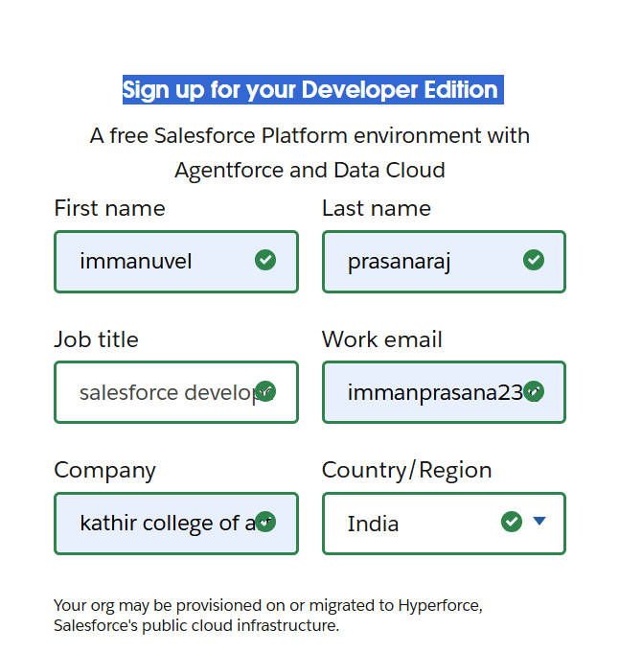

* **Created objects: Customer, Item , Customer Order**.

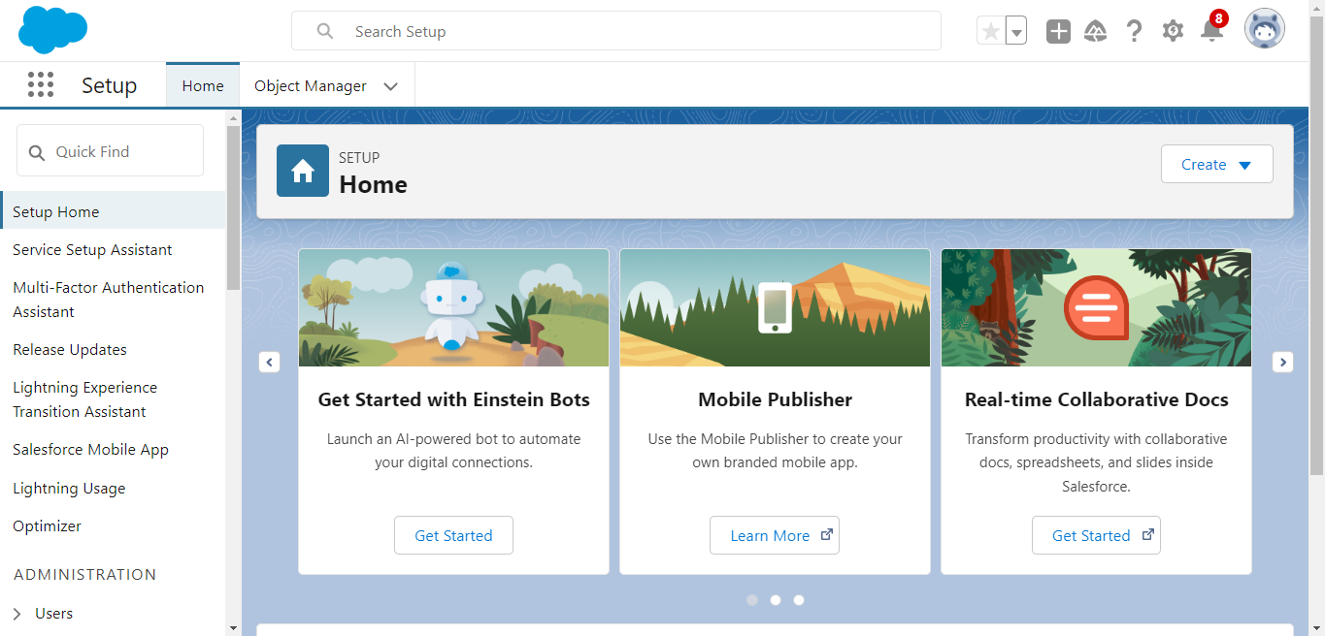

**Object**

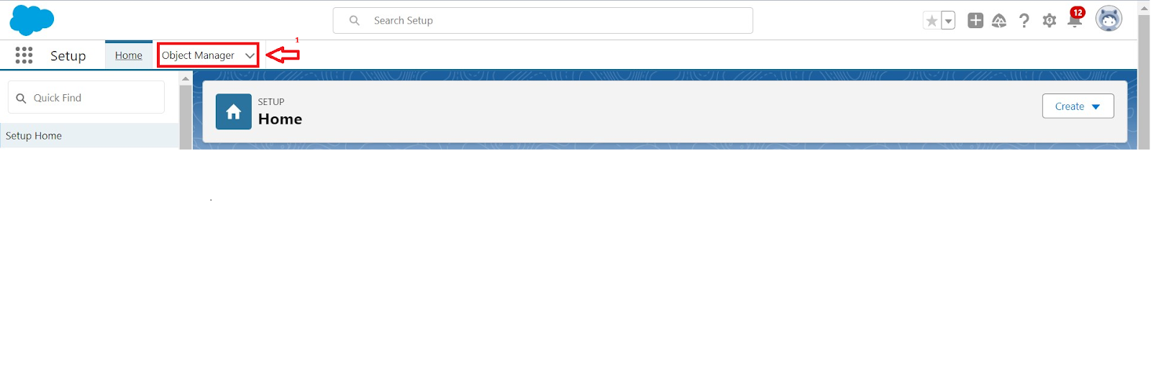

* **Creating a Custom Tab:**

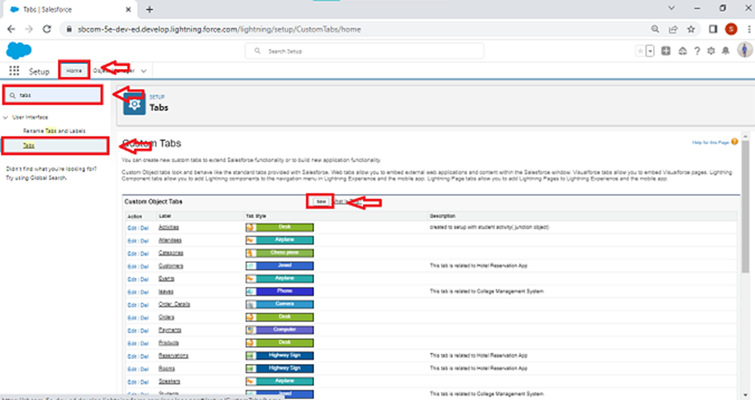

* **Developed Lightning App with relevant tabs**

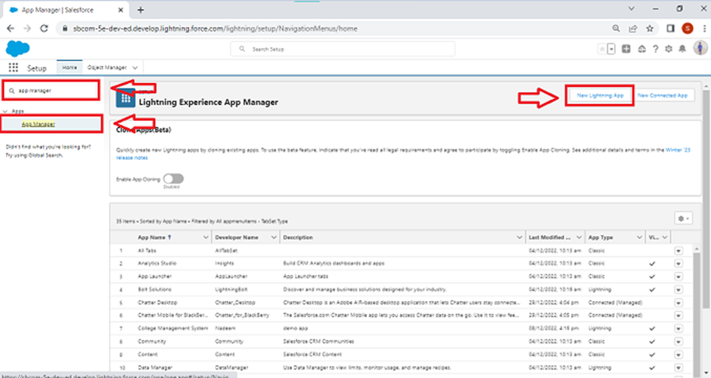

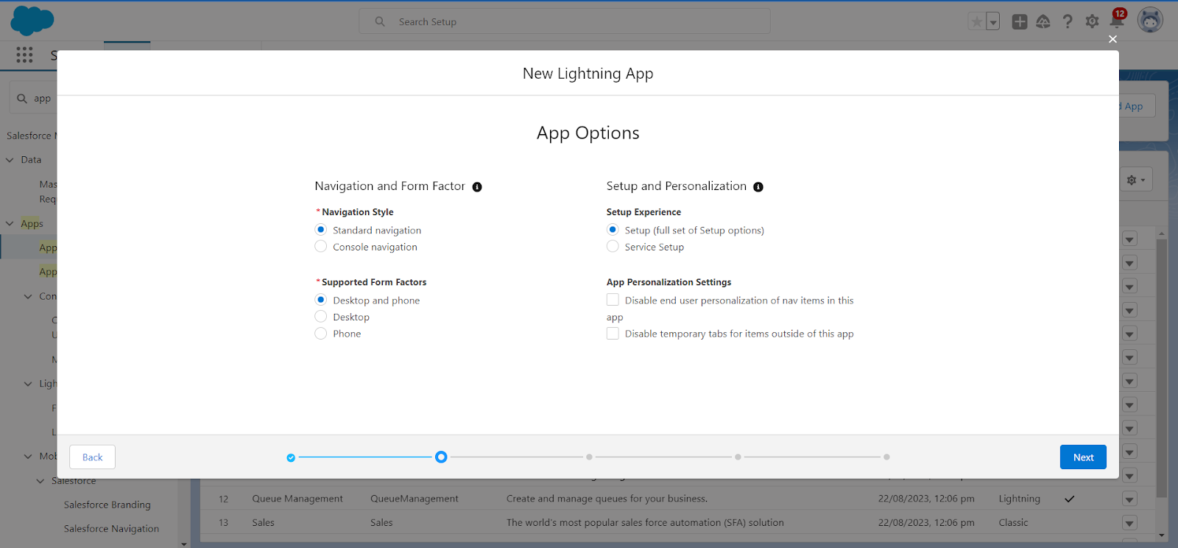

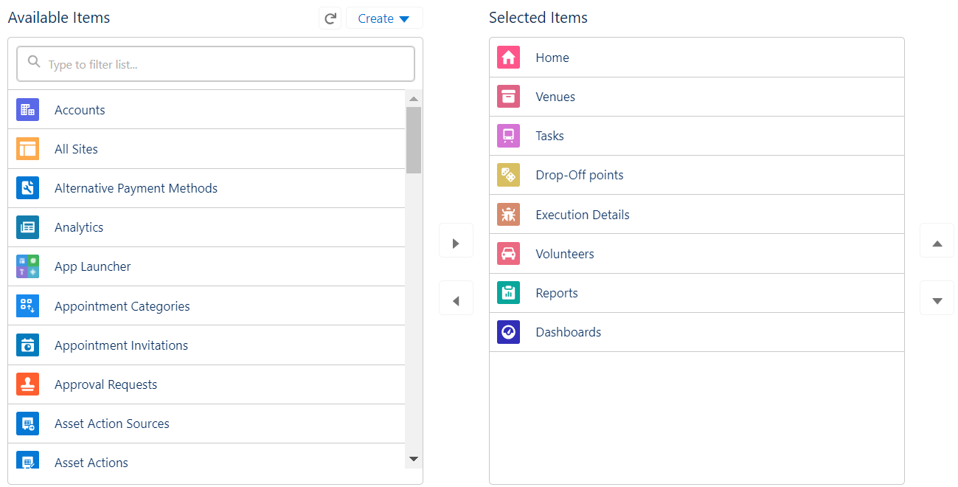

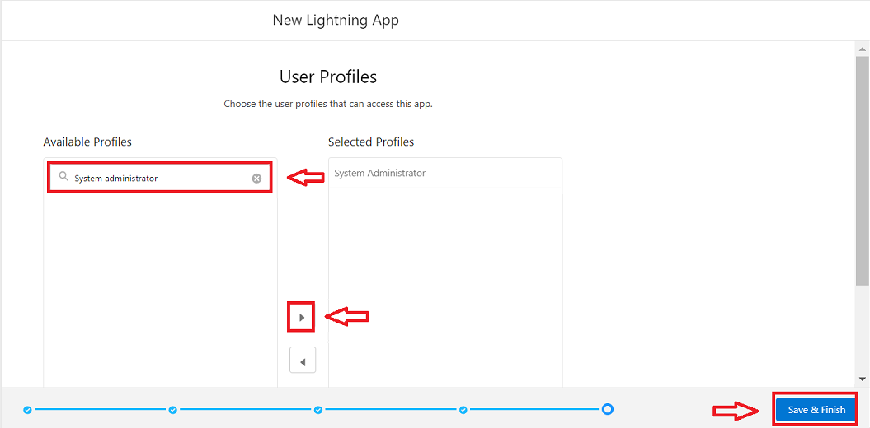

**Creating Lookup Relationship:**

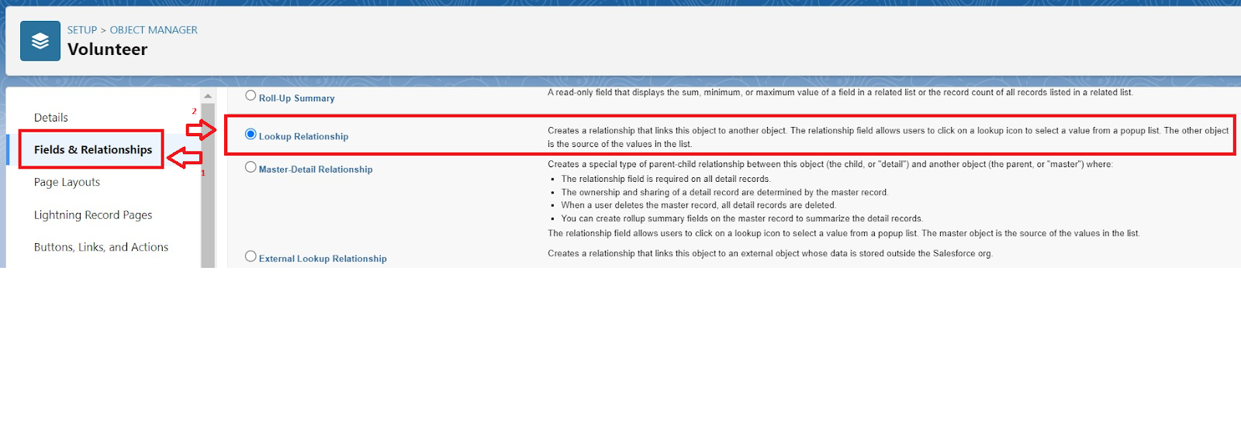

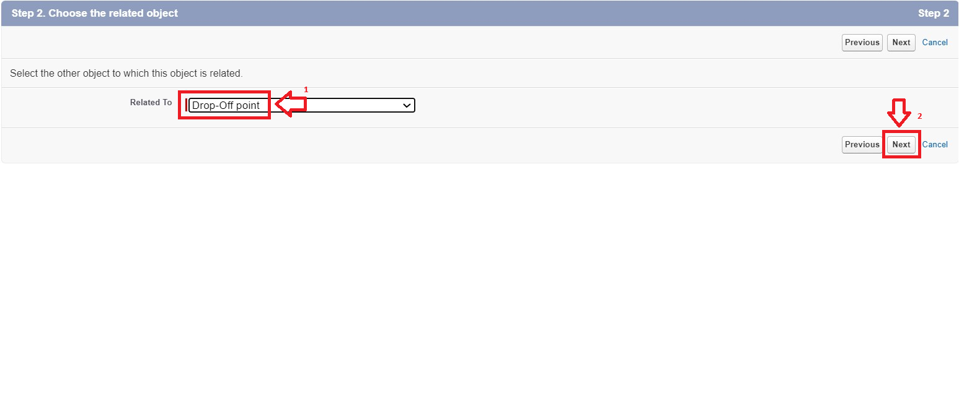

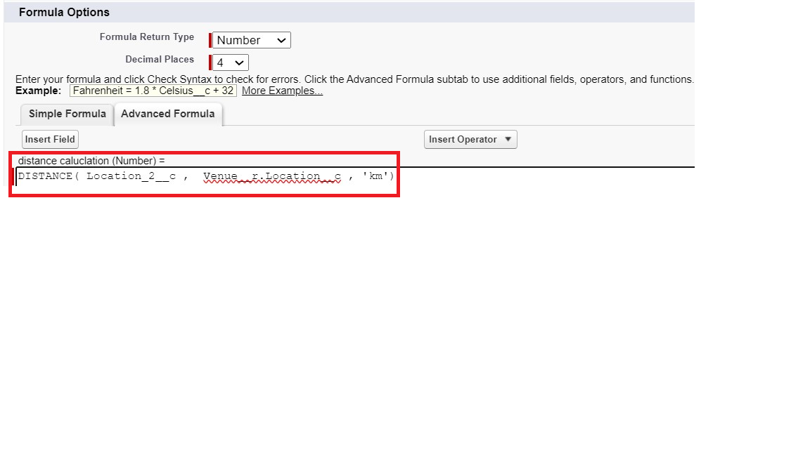

**To create a Flow:**

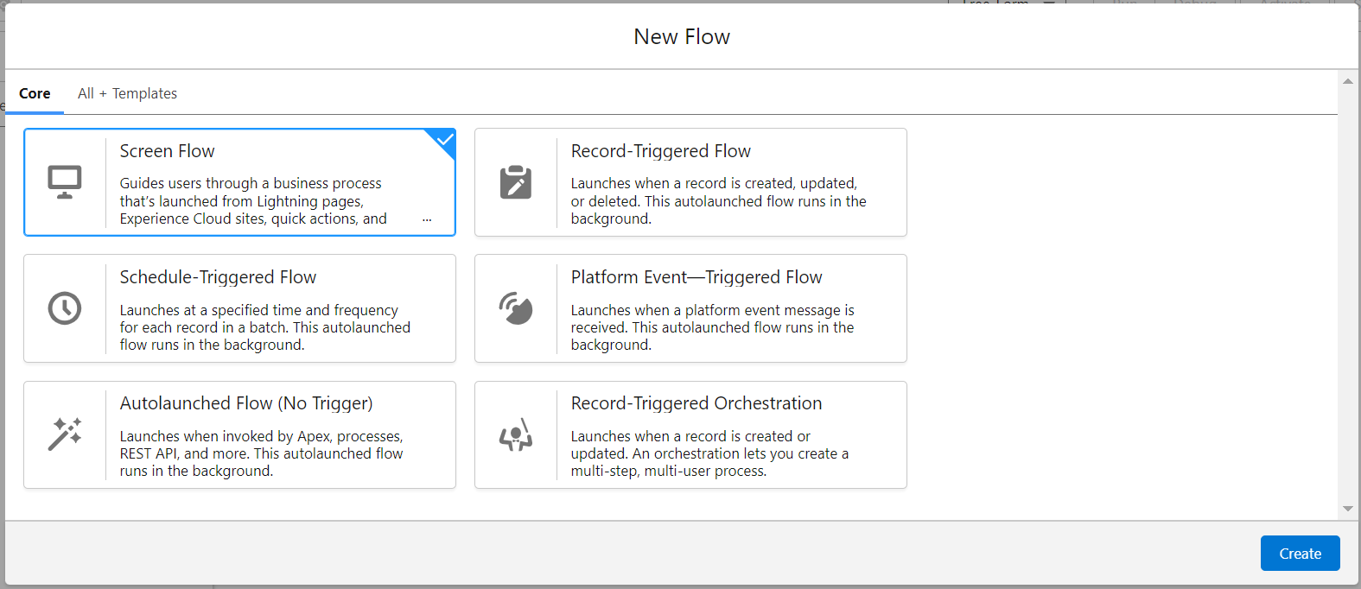

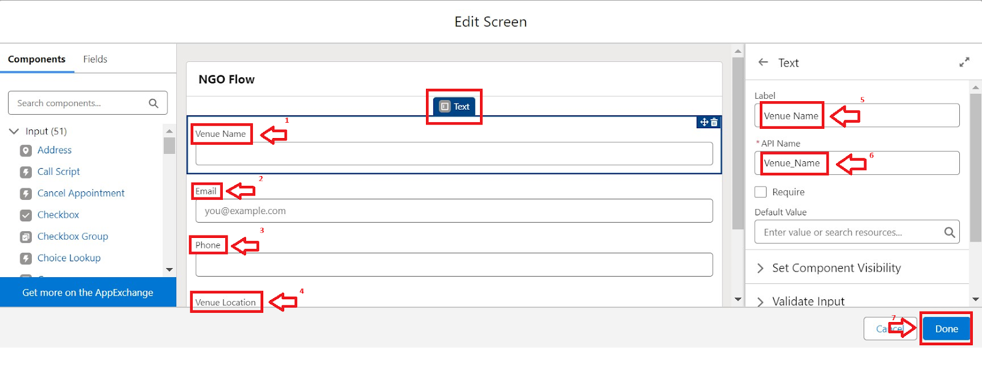

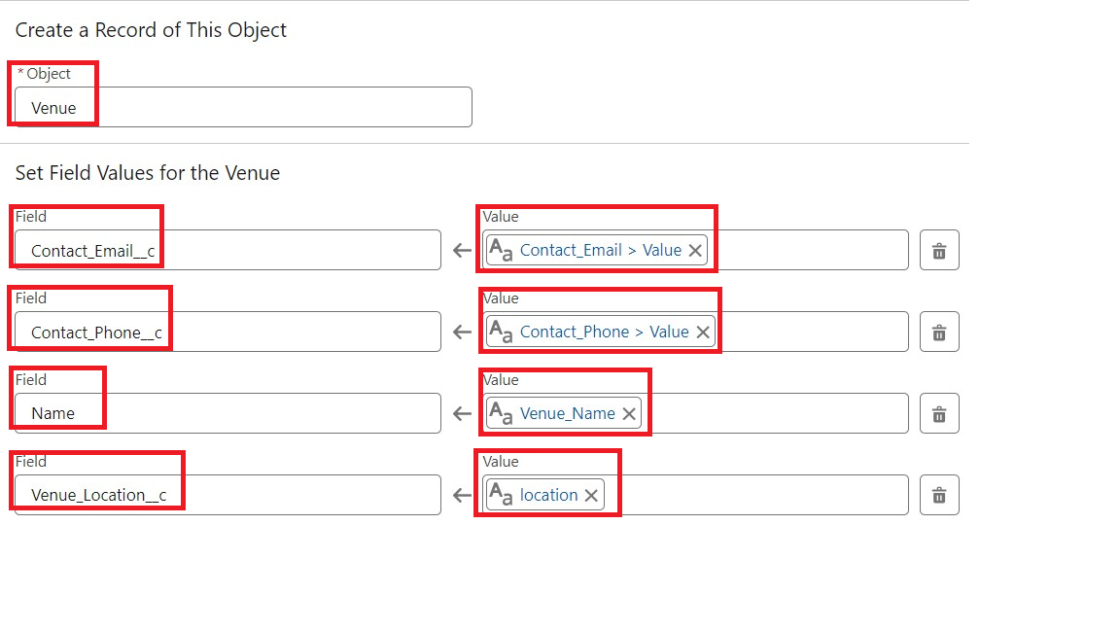

**To create a Trigger:**

j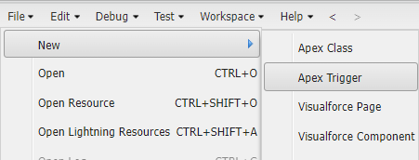

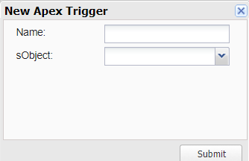

creation of users:

User1:

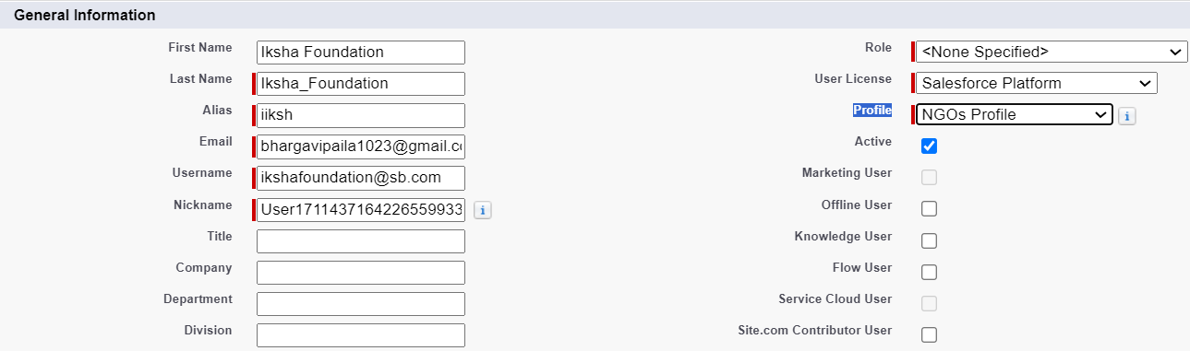



**To Create a Public** **Group :**

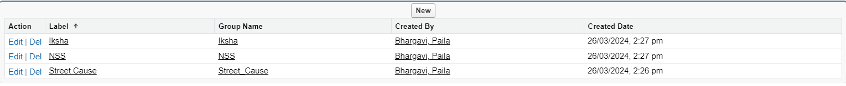

**Create Report Types:**

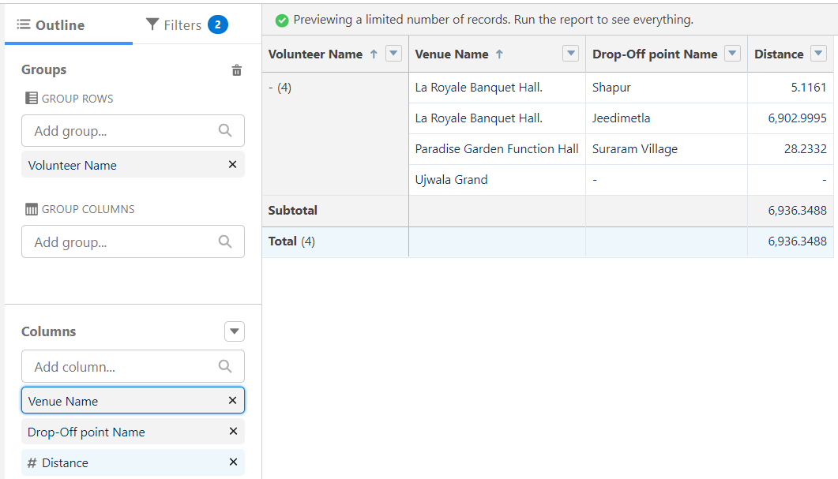

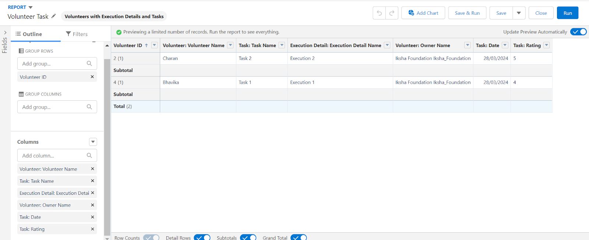

**To create a Dashboards:**

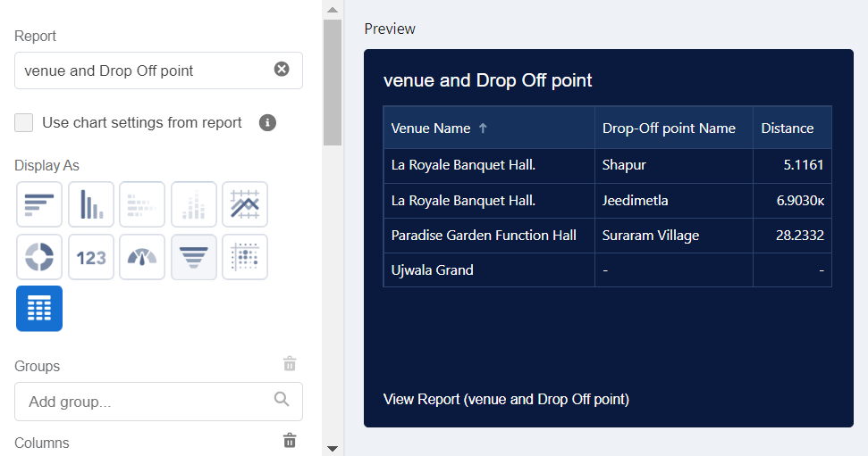

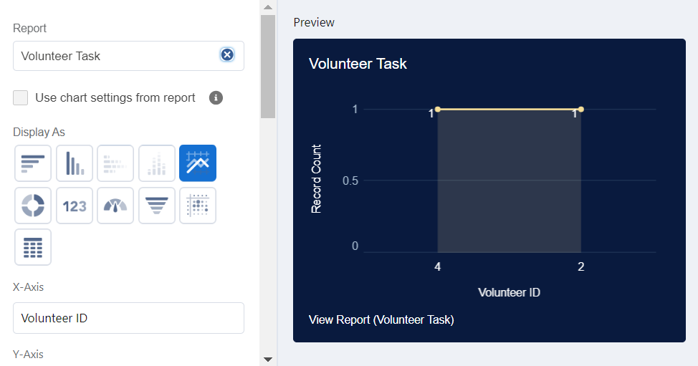

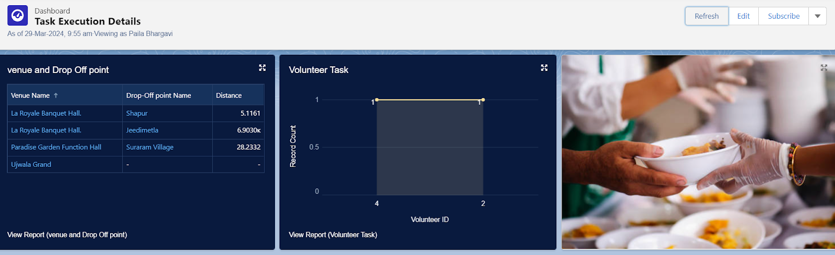

**Sharing Rules:**

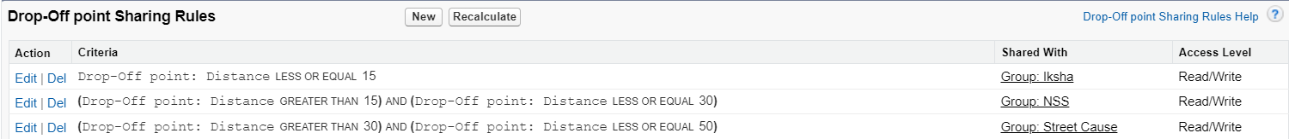

**To create a Home Page**:

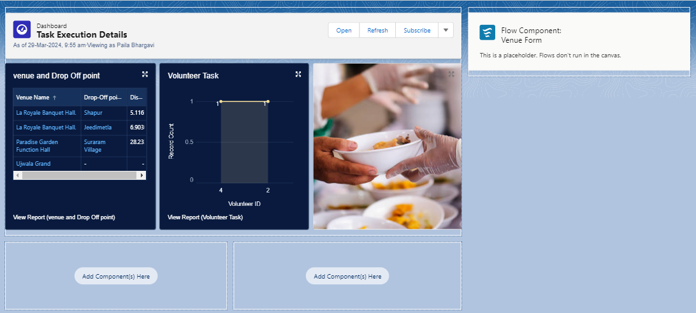

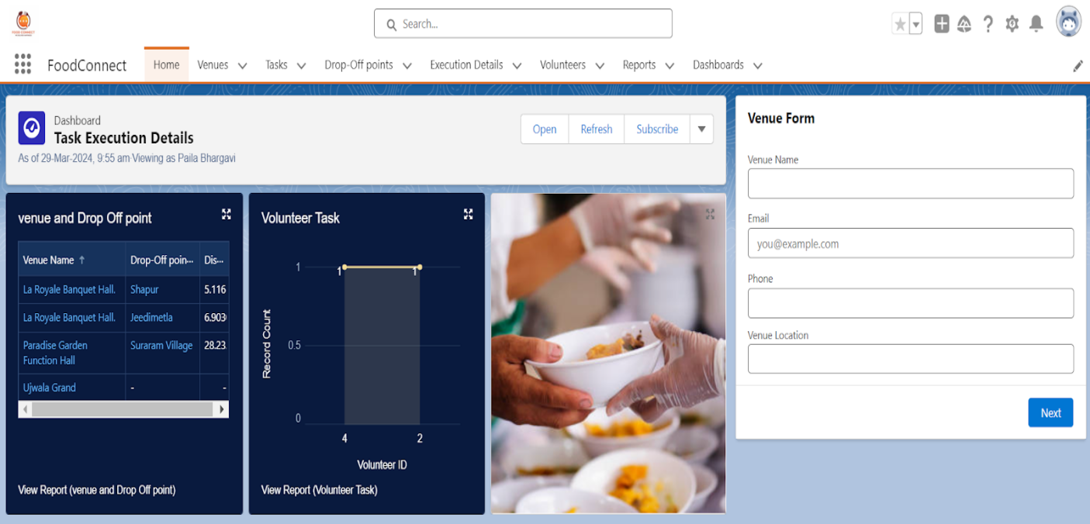

RESULT:

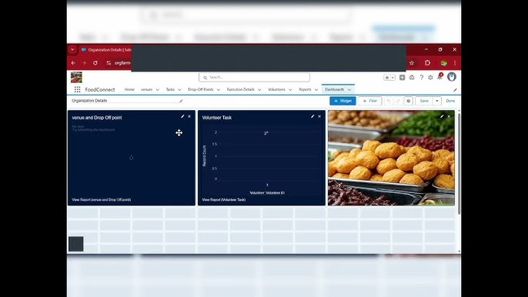

# CONCLUSION

# This project not only addresses hunger and malnutrition but also contributes to sustainable development by reducing food wastage. With collective efforts, we can ensure that “No food goes to waste, and no person goes hungry.”

# 

## APPENDIX

● **Source Code:** Provided in Apex Classes and Triggers

**CODE:**

**# Import necessary libraries**

**from flask import Flask, render_template, request, redirect, url_for**

**from flask_sqlalchemy import SQLAlchemy**

**app = Flask(_name_)**

**app.config["SQLALCHEMY_DATABASE_URI"] = "sqlite:///food.db"**

**db = SQLAlchemy(app)**

**# Define models**

**class User(db.Model):**

**id = db.Column(db.Integer, primary_key=True)**

**name = db.Column(db.String(100), nullable=False)**

**email = db.Column(db.String(100), nullable=False, unique=True)**

**class Food(db.Model):**

**id = db.Column(db.Integer, primary_key=True)**

**name = db.Column(db.String(100), nullable=False)**

**quantity = db.Column(db.Integer, nullable=False)**

**donor_id = db.Column(db.Integer, db.ForeignKey("user.id"))**

**# Define routes**

**@app.route("/")**

**def index():**

**return render_template("index.html")**

**@app.route("/register", methods=["GET", "POST"])**

**def register():**

**if request.method == "POST":**

**user = User(name=request.form["name"], email=request.form["email"])**

**db.session.add(user)**

**db.session.commit()**

**return redirect(url_for("login"))**

**return render_template("register.html")**

**@app.route("/login", methods=["GET", "POST"])**

**def login():**

**if request.method == "POST":**

**user = User.query.filter_by(email=request.form["email"]).first()**

**if user:**

**# Login logic**

**pass**

**return render_template("login.html")**

**@app.route("/food/list")**

**def food_list():**

**foods = Food.query.all()**

**return render_template("food_list.html", foods=foods)**

**@app.route("/food/request/<int:food_id>")**

**def food_request(food_id):**

**food = Food.query.get(food_id)**

**# Request logic**

**pass**

**if _name_ == "_main_":**

**app.run(debug=True)**